**Lab report – Fractals Assignment**

Submitted to **– Trevor Bakker**

Submitted by **– Vishesh Gupta**

Submitted on – October 9th, 2019

**LAB REPORT**

Purpose:

* *Using Parallel Programming to compute images in the Mandelbrot set*

Statement of the Problem:

* *In this experiment we try to generate an image that takes a fair bit of processing power, and optimize the time taken to generate the image using concurrency.*
* *We use the pthread library for this assignment, as it is one of the most widely known low level threading library and is suitable for this problem.*

Materials:

* *The code for this assignment is based on the code on the course GitHub Page: https://github.com/CSE3320/Fractal-Assignment*

Results:

Experimental Data from computing imageA. The command line argument is : time ./mandel -x -0.5 -y 0.5 -s 1 -W 2048 -H 2048 -m 2000 -n (1,2,3,4,5,10,50) -o mandelA.bmp

|  |  |
| --- | --- |
| Number of threads | Minimum time (out of 10) in seconds |
| 1 | 26.232 |
| 2 | 25.273 |
| 3 | 19.328 |
| 4 | 17.123 |
| 5 | 15.015 |
| 10 | 11.584 |
| 50 | 10.768 |

Experimental Data from computing imageB. The command used was : time ./mandel -x 0.2869325 -y 0.0142905 -s 0.000001 -W 2048 -H 2048 -m 1000 -n (1,2,3,4,5,10,50) -o mandelB.bmp

|  |  |
| --- | --- |
| Number of threads | Minimum time (out of 10) in seconds |
| 1 | 16.027 |
| 2 | 8.739 |
| 3 | 7.780 |
| 4 | 6.774 |
| 5 | 6.762 |
| 10 | 6.478 |
| 50 | 6.411 |

Resultant Graph:

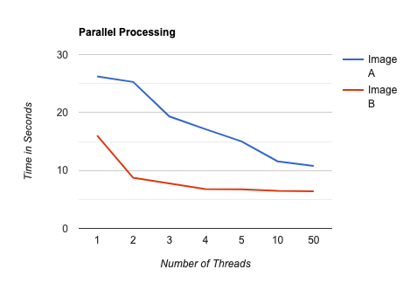

Conclusions:

* *The optimal number of threads for image A seem to be around 10.*
* *The time take for image B plateau at 4 threads so that seems like the optimal value.*
* *The two curves have differing shapes because the magnification for Image A was double the magnification of Image B and the size of Image A is 10^6 times the size of Image B*